Design Doc Template

Author(s): xyz
Date: 22/05/2019

Revision: 0
Document Status: Draft [Draft, Completed, Submitted, Reviewed, Final]
Project Status: In-Progress [In Review, Approved, In-Progress, Completed]

Revision History

Date | Revision | Description | Author
22/05/2019 | 0 | Initial draft of the design doc template | xyz

Table of Contents
TOC \o "1-3" \h \z \u Introduction4
Summary4
Background4
Definitions, Acronyms, and Abbreviations5
Design Overview5
Requirements5
Documentation5
Minimum Viable Product6
Stretch goals6
Future work6
Architectural Diagrams6
System Diagrams7
Application Programming Interface7
Recommendations7
User Interface7
Data Models and Storage7
Service Operability8
Key Performance Indicators8
Service Level Objectives8
Project Overview8
Communication and Tracking8
Risks8
Milestones8
Project Phases9
Cost9
Frequently Asked Question9
References9
Addendum9

Introduction

Summary
Non-technical project overview, also known as an executive summary or elevator pitch. Intended to quickly summaries the problem you are trying to solve.
em? Why can’t the existing tool
Human movement detection is vital in Telepresence robots,Animations,Games and Robotic movements.By using traditional methods with the help of sensor suits it is difficult to find and interpret the movements.It is also expensive and bulky too.Image processing and deep learning provides a solution to detect and interpret Human movement

Background
The problem statement, what are the issues you are trying to solve, what gaps currently exist, etc?
It is an irony however, that with massive investment in CCTV cameras to prevent crime has failed to have a significant impact, despite billions of rupees spent on the new technology. We always come across the news in media about breaking of ATMs, robbery at shopping complexes, at petrol pumps, at shops, crimes at different spots with all these happenings captured in CCTVs. Sometimes, the culprits play with the CCTVs before committing the crimes and most of the times they do not even bother about their acts of crime being recorded in CCTVs.

What are the existing tools that address these issues or gaps, and why do they not satisfy this problem? Why can’t the existing tools be updated to solve this problem?
Currently only cctv footage with human supervision is used for surveillance.
Since human cannot always be always active this method failed

What overlaps will your solution have and how is it differentiated from the existing tooling.
We are using Deep learning technique to address the issue so automation is possible by this technique and human surveillance is not required and no wait time is required.

What are the gains / wins from creating this tool / solution?
Enhanced customer satisfaction
High-grade service solutions
Proactive and responnsive
One-time investment for timeless merits.
Higher accuracy than a human expert.

Definitions, Acronyms, and Abbreviations
Definition of terms that will help readers understand the documents, or acronyms common in your project area
AI:Artificial intelligence is a software that allows humans to perform complex tasks easily.Generally we say that AI is cognitive because of its self learning datastreams which improve by themselves.

Design Overview

Requirements
Project requirements, this can include requirements from customers, partners, or overseeing teams. The requirements for the project, this may include subsections for various types or sources of requirements
Cameras
images
internet access

Documentation
If the project requires any wiki pages, code comments, presentations, etc. that information should be included here
Recurrent Human Pose Estimation-IEEE
Personalizing Human Video Pose Estimation-IEEE

Minimum Viable Product
A detailed description of the deliverable for this project, this is the minimal functionality required for the project to be considered successful and should not include stretch goals or future work.

AI security surveillance helps helps keep criminals away because burglars don’t want them video of them to be captured while comiting them.

Stretch goals
Stretch goals include functionality beyond the scope of the minimum viable product that should be include in the project should time and budget permit. Unlike future work, stretch goals would be smaller tasks for features in support of the minimum viable product.
No wait time
Higher customer satisfaction
Improved ease of use
Automatic recognition of critical situations.

Future work
This may include ongoing support, expansion of the original scope, work that requires transitions in project ownership, or details of projects designed to be broken up into multiple phases.
At the start we are concentrating on small scale but once our approach is succesfull we want to implement our code in military applications which fights for the country.

Architectural Diagrams
UML diagram describing the project. You can look for any open source diagramming tool for the same.
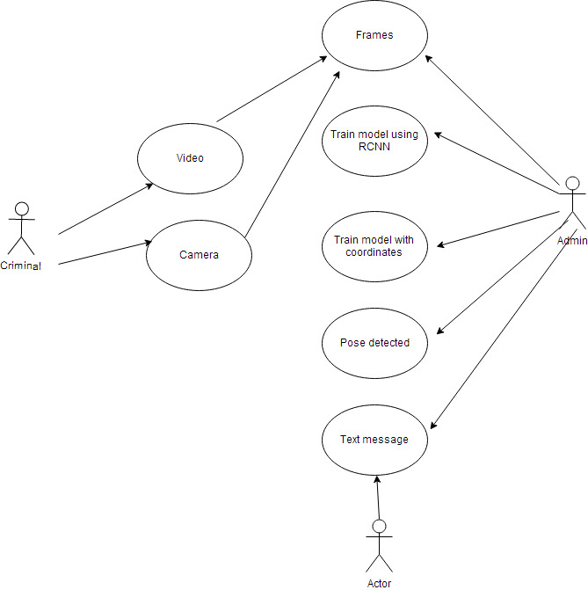
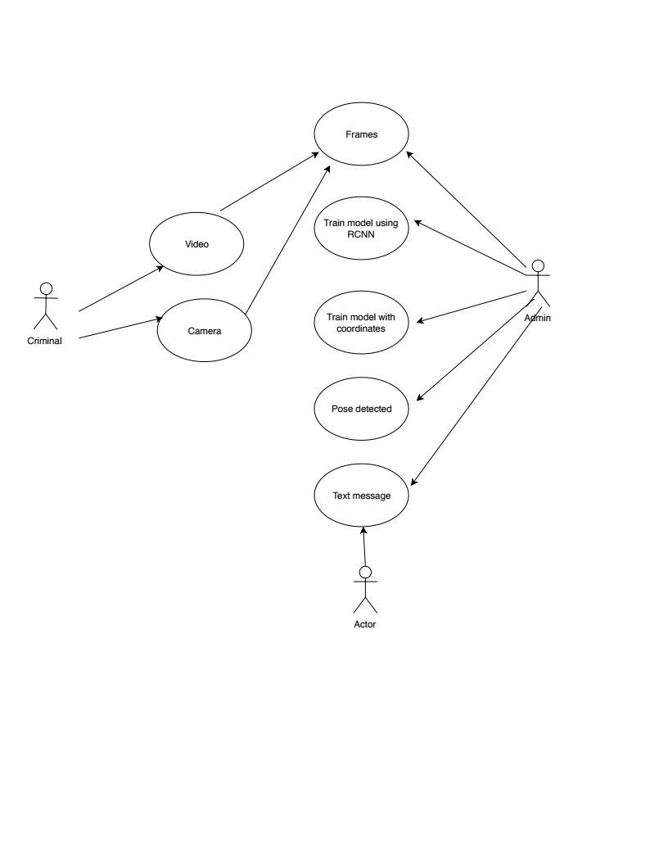

System Diagrams
This section, sometimes referred to as a ‘System Context Diagram’, would typically consist of a UML diagram which illustrates the boundary and interaction with external systems. For a CLI this may show which backend systems provide the data, for services it may indicate dependencies such as databases, Kafka, or downstream services.

Application Programming Interface
For services, libraries, and command line interfaces that present an interface which can be wrapped

Recommendations
Using a versioned endpoint simplifies the process of making future backwards incompatible API changes;
/api/v0

User Interface
For frontends, a mockup canbe attached to illustrate the user interface. Command line interfaces may include a list of subcommands and their options.

Data Models and Storage
For projects requiring messages queue such as Kafka, MySQL, etc.
Kafka
- How many partitions are needed for this topic?
- How many days of retention will be needed?
- What will the partitioning key become?
- How much data will be written to the topic during peak hours?
- What type of Kafka cluster will be needed? (E.g. aggregate, queuing, tracking, metrics, logging)
MySQL
- What does the table schema look like and how are they all tied together (provide a UML)?
- What sort of updates will be made to the tables?
- How will users make queries to the tables? (e.g. Complex joins, pre-filtering, single record gets)
- What the strategy for indexing?

Service Operability

Key Performance Indicators
Key performance indicators (KPI), describe how a service should be monitored and how its performance can be gauged. This would typically include an overview of the types of metrics an application will need to emit, call time, error rate, etc.

Service Level Objectives
Service level objectives (SLOs), set targets for various KPI through alerts via email or SMS, these targets may provide early indicators of approaching a capacity limit, changes in load patterns through various phases of an application, changes in duration of offline processing, etcy.

Project Overview

Communication and Tracking
Any relevant distribution lists, slack channels, taiga projects, etc
Communication can be done through App store,google play,web application,word of mouth

Risks
Anything that may put the project at risk; potential delays, dependence on work done by other teams, hardware procurement, or reviews.
Risks may also include assumptions of the project's external dependencies. These may be lower level project dependencies that are tracked outside of the immediate project scope and assumed to already be in place. For example, "project x assumes OS version y will be available in the market."

Milestones
Estimated dates when planning steps, deliverables, and reviews will be completed

Project Phases
For projects that are better tracked and reported on in multiple phases because of extended timelines, external dependencies, etc

Cost
Level of effort, number of resources, number of hours or weeks, unlike milestones which tracks project time cost should only include engaged time.
1) For the all tasks which are deliverables/visible on user-end side needs to be documented as stories.
2) Need to guess/estimate the time required in number of hours for the completing that stories which can be captured in taiga.
3) Assign that task to the right person and document the actual time taken for completing that task.

Frequently Asked Question

References
Links to any supporting documentation, other projects, or reference material
ieeexplore.ieee.org/document/7780703
https://ieeexplore.ieee.org/document/8100084

Addendum
Additional diagrams or details that do not particularly belong in the body of the design doc. This could also be a place to describe additional examples that would otherwise bloat the introduction section. More specifics on APIs could also be placed here for engineers to reference.

